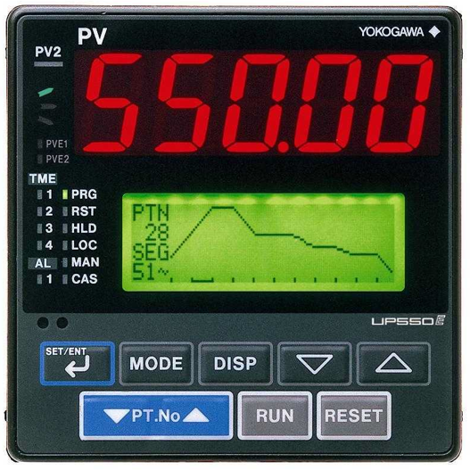

To Programming the Controller,

- If RST is not on, press and hold the “RESET” button for at least 2 seconds until the RST indicator is on.
- Press and hold “SET/ENT” button for at least 3 seconds until “PROG programming main menu” in the display.
- Press “SET/ENT” button once to display “LOC local mode set sub menu”
- Press “Up” button to display “PRG programming sub menu”
- Press “SET/ENT” on more time:
  - Top display shows the pattern # (1~30)and sequence # “01.00”
  - Lower display shows:
    - MENU: PROG/PRG #1
    - PTno. Input
    - PTN=1
  - To change the program pattern number (here shows number 1), use UP and Down arrow buttons. Then press “SET/ENT”.
- Press “SET/ENT” twice to modify the (Start Set Point) SSP1.
- Press “SET/ENT” once and make sure (Start Code) STC=0
- Press “SET/ENT” once, top display show pattern # and sequence # “01.01”, use UP/Down arrow to set (Target Set Point) TSP1 value, then press “SET/ENT”.
- Press “SET/ENT” once again to modify the time “0h00” need to reach the TSP1. Use UP/Down arrow to change the time. “1h30” means 1 hr 30 minutes. Press “SET/ENT” to set the value.
- Press “SET/ENT” twice and make sure (Event Identifier) EV1=0
- Press “SET/ENT” once and make sure (Junction Code) JC=0
- Repeat step 8~11 to finish next sequences. Top display shows pattern # and next sequence #. Modify lower display TSP, Time, keep EV1=0 and JC=0. Same TSP1 as previous TSP1 will create dwell segment. To end the program, Leave the segment time value as a dash”-“ only.
- Press “DISP” 3 times to exit the Programming.

To Run a Program:
(If excess temp controller “AL1 OUT” is on. Make sure the top display value<lower display value, press and hold UP arrow at least 1 seconds to turn off the “AL1 OUT”)
- Use the “Pt.no” button to select the program pattern number.
- Press and hold “Run” button at least 2 seconds. The selected program will start and the “PRG” will be on.
- To stop a running program, press and hold “RESET” button for at least 3 seconds. The program will stop and “PRG” will be off and the “RST” will be on.
- To place a hold on a running program, press “MODE”, the lower display will show :”Hold:ON”; Press “SET/ENT”, the “HLD” turns on. To continue program, press “MODE” again, the lower display will show :”Hold:OFF”; Press “SET/ENT”, the “HLD” turns off.

